**Session report 04/04/2023:**

*LABAUVIE – RAFFAELLI EVA*

*ROB3*

During this session I finally had all the pieces to try to bring the wheel together.

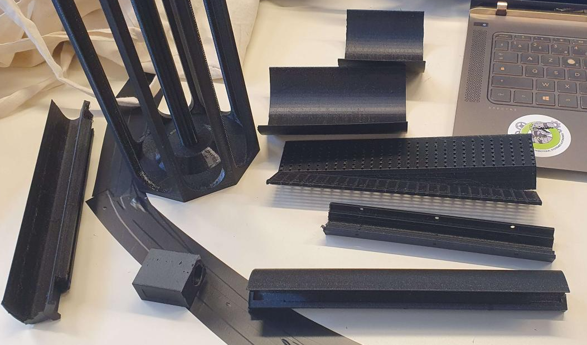

I filed the pieces so they fit better on the wheel.

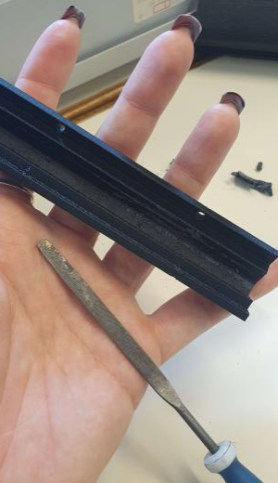 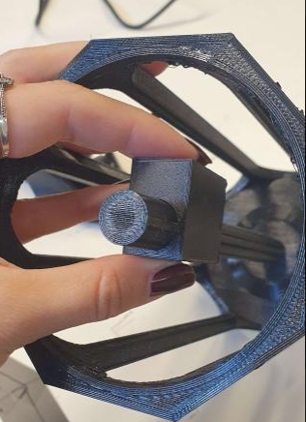

Here is one attempt of attaching them all together (the screws are purposelhy too big, it was only for the try).

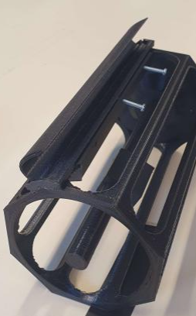 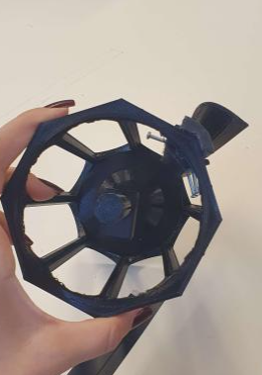

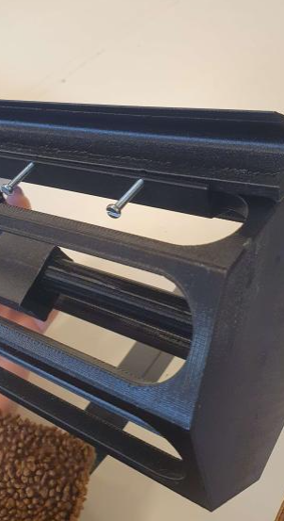

Next, I went back to the Nvidia card, trying to start over Yolo installation and working directly on the card.

<https://gilberttanner.com/blog/jetson-nano-yolo-object-detection/>

<https://roboticsknowledgebase.com/wiki/computing/setup-gpus-for-computer-vision/>

I based myself on these tutorials.

First, I followed the setup tutorial so I can start running Yolo the right way :

I installed perquisites

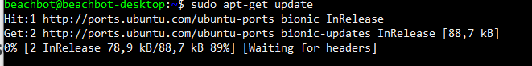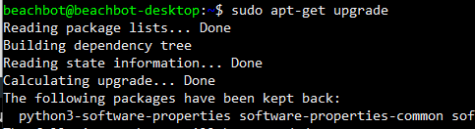



Since I am on ubuntu 18 :

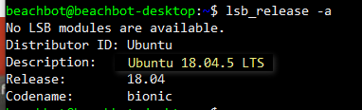

I had additional steps :



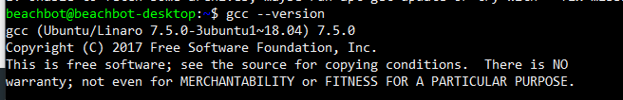

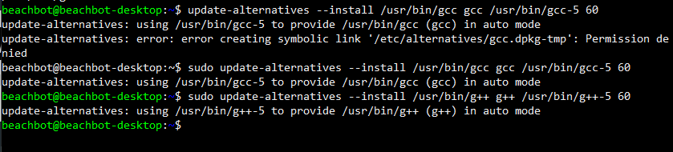



I have an error called “EPI variables are not supported on this system” so I need to find an answer to be able to continue.